**Name :**

**Roll no :**

**Group B Lab Assignment:** 9

**Subject :**PSDL

**Title :** LCD interfacing with PIC18Fxxx.

**Assignment No: 9**

**Title :** Embedded C program for LCD interfacing with PIC18Fxxx.

**Aim :** To write a C program to interface PIC18F4550 to 16x2 Character LCD.

**Experimental Setup:** MicroPIC18F board, USB cable, Power supply adaptor, MPLABx IDE, PICLoader software.

**Objective:**

* To Perform interfacing of real-world input and output devices to PIC18FXXX microcontroller.
* To write and execute an Embedded C program to interface PIC18F4550 to 16x2 Character LCD.

**Theory:**

**1). LCD 16x2 Display Module**

LCDs (Liquid Crystal Displays) are used for displaying status or parameters in embedded systems. Liquid Crystal Display (LCD) is widely used in various electronics’ applications. It is commonly used in various systems to show different status and parameters.

LCD16x2 has 2 lines with 16 characters in each line. Each character is made up of 5x8 (column x row) pixel matrix. LCD 16x2 is a 16 pin device which has 8 data pins (D0-D7) and 3 control pins (RS, RW, EN). The remaining 5 pins are for supply and backlight for the LCD.

The control pins help us configure the LCD in command mode or data mode. They also help configure read mode or write mode and also when to read or write.

LCD 16x2 can be used in 4-bit mode or 8-bit mode depending on the requirement of the application. In order to use it, we need to send certain commands to the LCD in command mode and once the LCD is configured according to our need, we can send the required data in data mode.

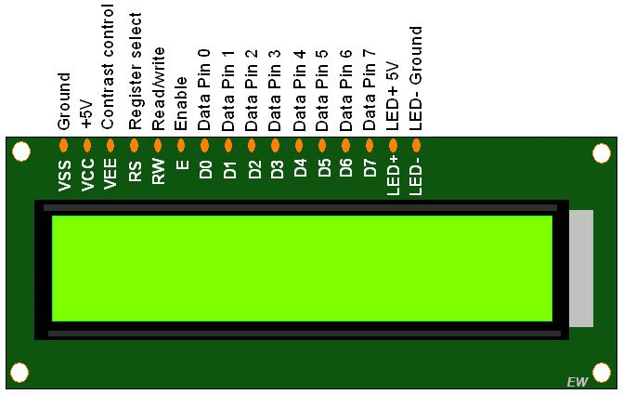

**LCD16x2**

**2). Interfacing Diagram:**

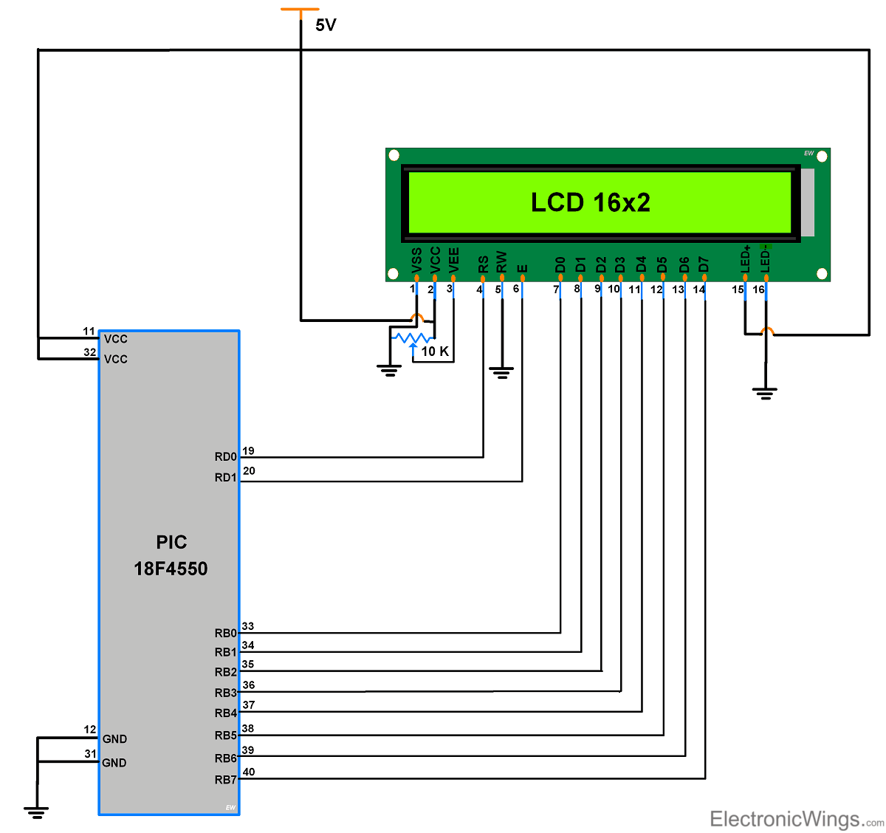

* LCD16x2 Power on delay: After the LCD16x2 powers ON, we cannot send commands immediately to it since it needs a self-initialization time of 15-ms. Therefore, while programming, we need to take care of providing sufficient power ON delay (> 15 ms), and then send a command to the LCD.
* After providing commands to execute, LCD16x2 takes time in microseconds but for 0x01 command (Clear display), it takes 1.64ms to execute. So after giving this command, we need to give sufficient delay> 1.63milliseconds.

**Procedure:**

**Step1:** Open MPLABX IDE on the PC for program development and create a new project and save it in a new folder.

**Step2:** Write the program in C language for interfacing 16x2 LCD to PIC18F4550. (in program properties make sure to add the 0x800 offset)

**Step3:** Build the program and create hex file. In case of errors correct program and rebuild to create hex file.

**Step4:** Prepare the experimental setup by connecting the MicroPIC18F board to the PC using USB cable. Power ON the Board. Check for the USBtoSerial COMx allocated by the PC**.**

**Step5:** Using the PICLoader Software flash the hex file in the PIC18F4550.

**Step6:** Press reset button and execute the program.

**.**

**Source code :**

#include <p18f4550.h>

#define LCD_EN LATAbits.LA1

#define LCD_RS LATAbits.LA0

#define LCDPORT LATB

void lcd_delay(unsigned int time)

{

unsigned int i , j ;

for(i = 0; i < time; i++)

{

for(j=0;j<100;j++);

}

}

void SendInstruction(unsigned char command)

{

LCD_RS = 0; // RS low : Instruction

LCDPORT = command;

LCD_EN = 1; // EN High

lcd_delay(10);

LCD_EN = 0; // EN Low; command sampled at EN falling edge

lcd_delay(10);

}

void SendData(unsigned char lcddata)

{

LCD_RS = 1; // RS HIGH : DATA

LCDPORT = lcddata;

LCD_EN = 1; // EN High

lcd_delay(10);

LCD_EN = 0; // EN Low; data sampled at EN falling edge

lcd_delay(10);

}

void InitLCD(void)

{

ADCON1 = 0x0F;

TRISB = 0x00; //set data port as output

TRISAbits.RA0 = 0; //RS pin

TRISAbits.RA1 = 0; // EN pin

SendInstruction(0x38); //8 bit mode, 2 line,5x7 dots

SendInstruction(0x06); // entry mode

SendInstruction(0x0C); //Display ON cursor OFF

SendInstruction(0x01); //Clear display

SendInstruction(0x80); //set address to 1st line

}

/********************************************************************************************************************/

unsigned char *String1 = "Microembedded";

unsigned char *String2 = "PIC-18F Board";

void main(void)

{

ADCON1 = 0x0F;

TRISB = 0x00; //set data port as output

TRISAbits.RA0 = 0; //RS pin

TRISAbits.RA1 = 0; // EN pin

SendInstruction(0x38); //8 bit mode, 2 line,5x7 dots

SendInstruction(0x06); // entry mode

SendInstruction(0x0C); //Display ON cursor OFF

SendInstruction(0x01); //Clear display

SendInstruction(0x80); //set address to 1st line

while(*String1)

{

SendData(*String1);

String1++;

}

SendInstruction(0xC0); //set address to 2nd line

while(*String2)

{

SendData(*String2);

String2++;

}

while(1);

}

**Result:** Check if the characters are getting printed on the LCD screen.

**Conclusion:** Thus, we have studied C program to interface PIC18F4550 to 16x2 Character LCD.